**Cura setup for S3D printer**

**Download Cura**

Visit this link http://t.cn/RSI22Ib

Choose the lastest version for your computer (available for Windos, macOS and Linux)

Choose "I don't want to share any information" to download

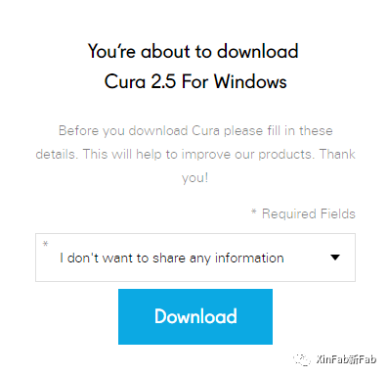

**Add Printer**

1. Choose "Custom - Custom FDM printer"

Name the printer as "S3D"

Click the botton "Add Printer"

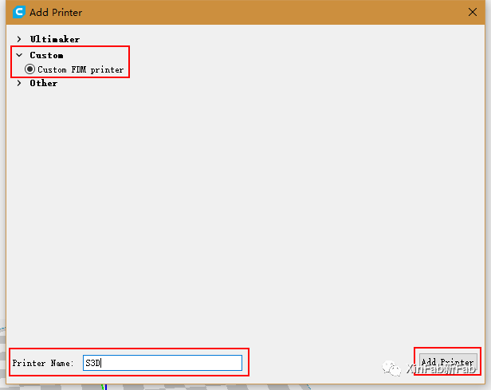

2. Machine Settings

Printer Settings

X (Width): 160 mm

Y (Depth): 160 mm

Z (Height): 160 mm

Build Plate Shape: Rectangular

Heated Bed: Checked

GCode Flavor: RepRap(Marlin/Sprinter)

Printhead Settings

X min: 20 mm

Y min: 20 mm

X max: 30 mm

Y max: 30 mm

Gantry height: 60 mm

Nozzle size: 0.4 mm

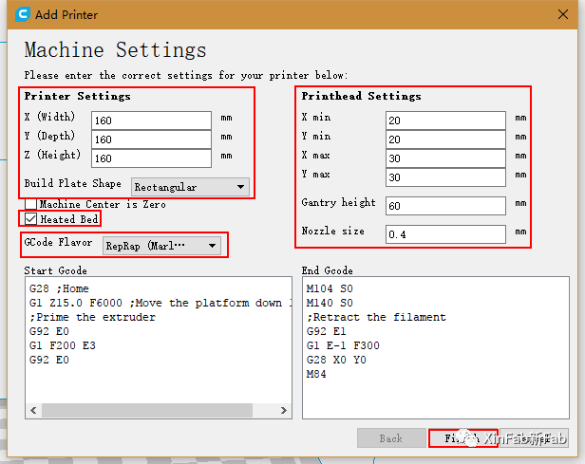

**Print Setup**

1. Look at the settings window in the right,

Material: PLA

Print Setup: Custom

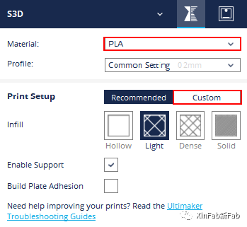

2. Make sure your default settings are same as bellow:

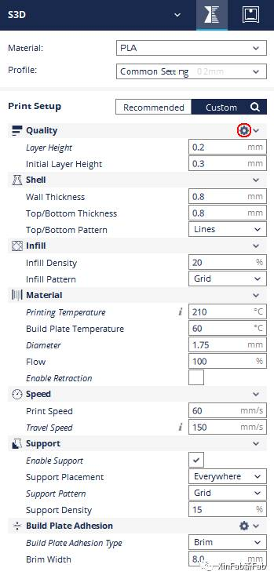 If you don't have the complete settings showing in the picture, please hover your mouse on the column of "Quality" and a gear will appear.

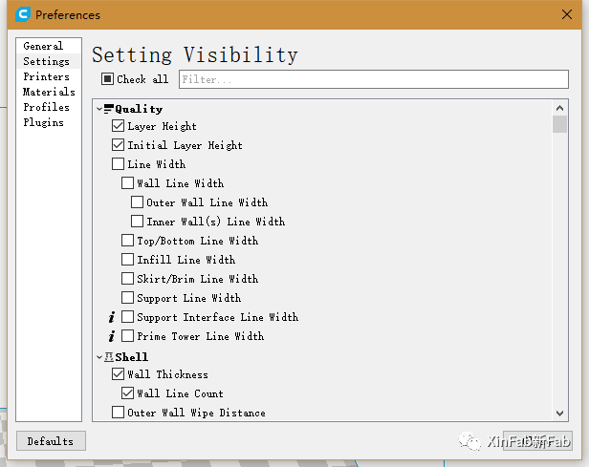 Click it to open the "Setting Visibility" window and select the settings you need.

**Check the Model**

1. Open your stl file

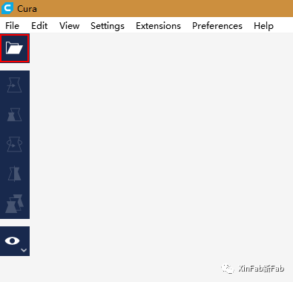

2. Click on your model and use the tools on the left side to find a perfect position to print.

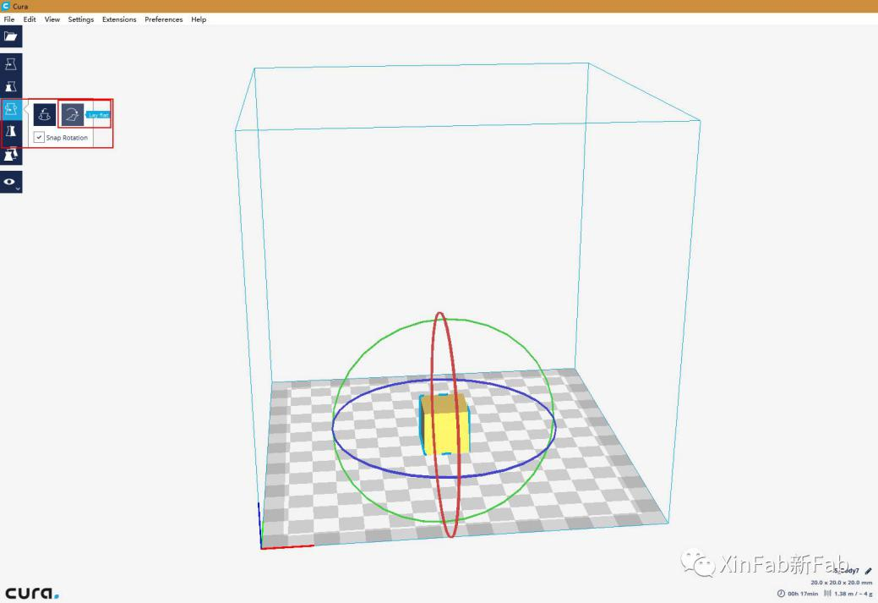

3. Please check the estimated printing time and material cost on the right bottom.

Based on this, you can adjust the settings to what you expect.

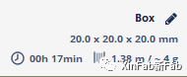

4. Save your file as ".gcode" file into the sd card.

